

**CSE4022 – Natural Language Processing**

**Project Report**

TITLE – RHYMER DICTIONARY

**B.Tech(IT),Winter -2018-19**

**Submitted By:**

Ritveak Dugar

(16BIT0407)

**OBJECTIVE:**

The objective of this project is to find a set of rhyming words with a particular word which is somehow related to an another given word.

**List of Libraries used:**

1. Pronouncing: Used for finding rhyming words, this library uses cmudict as corpus reference to find phonetically resembling words to a given word.

2. re: Required for using regular expression for string comparison.

3. sys: Required for using sys.exit(), to exit the program.

4. wordnet: Required for finding synonyms, hypernyms, hyponyms, holonyms and meaning of words.

**Code:**

import pronouncing

import re

import sys

from nltk.corpus import wordnet

import nltk

# a proper module separately made for finding rhyming words; also based on cmudict.

print("Enter the word whose rhyming word you wish to find : ")

iword = input()

fb = pronouncing.rhymes(iword)

#Simple synonym set

rr=[]

print("Enter the word whose meaning should resemble with the rhyming word \n(enter \"*\" if you wish to see all rhyming words) : ")

mword = input()

if(mword=="*"):

print(fb)

sys.exit()

syns=wordnet.synsets(mword)

for syn in syns:

rr+=syn.lemma_names()

#Since simple synonym set is not enough, lets add more related words

#finding all related words among which rhyming words is to be found

hr=[]

syns=wordnet.synsets(mword)

for syn in syns:

sn=syn.hypernyms()#broader category:colour is a hypernym of red.

an=syn.hyponyms() #narrower category - red : color

dn=syn.member_holonyms()#Body is a holonym of arm, leg and heart

for s in sn:

hr+=s.lemma_names()

for a in an:

hr+=a.lemma_names()

for d in dn:

hr+=s.lemma_names()

#making the list richer by adding synonyms of the words which are in hr.

fn=[]

for h in hr:

ss=wordnet.synsets(h)

for s in ss:

fn+=s.lemma_names()

fn = list(dict.fromkeys(fn)) # removing duplicates

#now selecting only the words that are common in both

import re

fo = list(set(fb)&set(fn))

for chk in fb:

for chk1 in fn:

my_regex = r".*" + re.escape(chk) + r"$"

found =(re.search(my_regex ,chk1, re.M|re.I))

if found:

fo.append(found.group())

fo=list(set(fo))

print(fo)

mean=input("If you wish to see the meaning and other details \nof the resulting words enter 1 else 0")

if(mean=="0"):

sys.exit()

from nltk.stem import WordNetLemmatizer

l = WordNetLemmatizer()

for det in fo :

print("The details of the word \""+ det +"\" are as follows:\n")

ld=l.lemmatize(det)

lw=wordnet.synsets(det)

print("Main Word - " + ld +"\n" )

print("Meaning - "+ lw[0].definition() +"\n")

**Flowchart:**

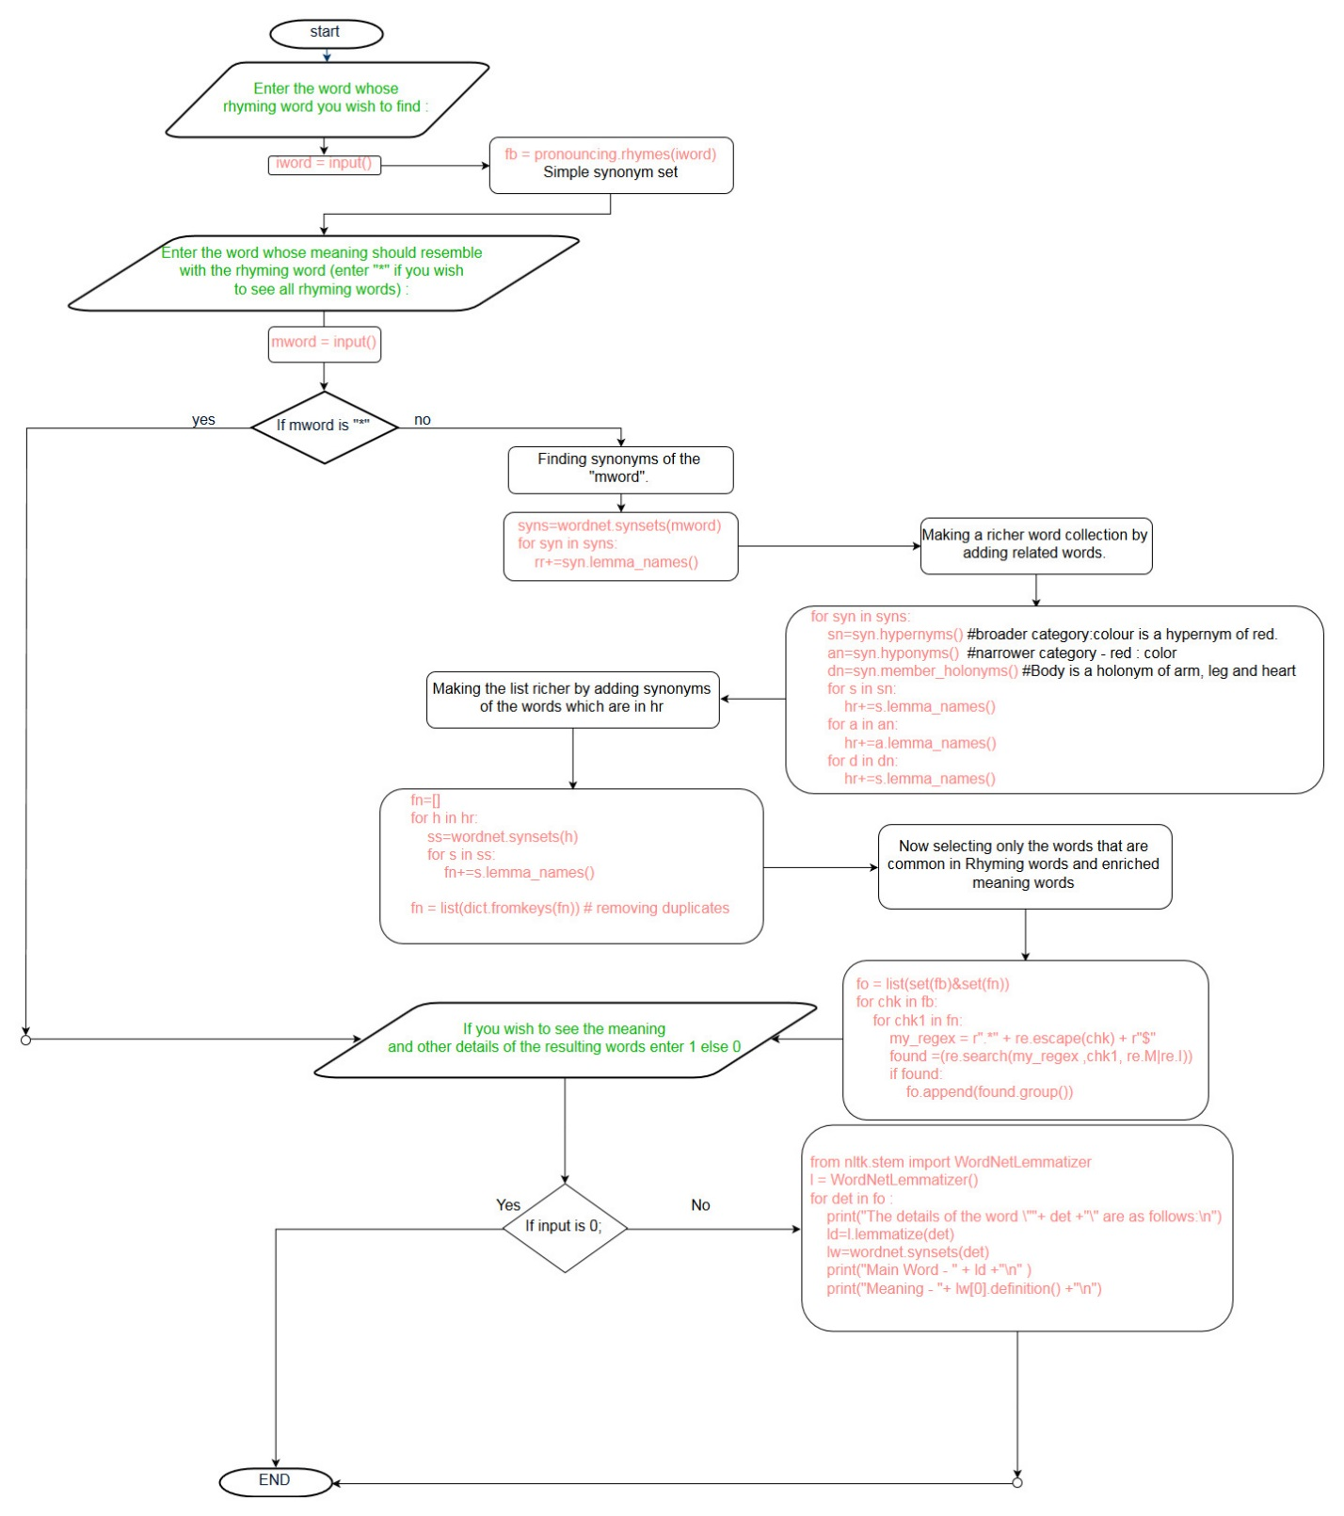

**Github Link :**